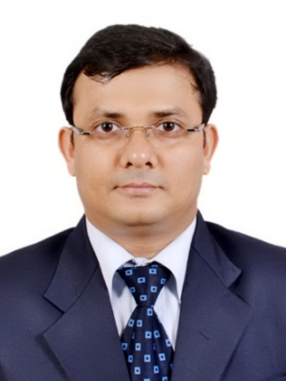
Short CV (06/2015)
Dr. Sujit Kumar Ghosh
Associate Professor, Chemistry
IISER Pune, Pashan, Pune- 411008, India
Phone: +91 20 2590 8076
E-mail: sghosh@iiserpune.ac.in/
sghoshchem@gmail.com

Academic and Professional Backgrounds:
2015 – Associate Professor
2009 – 2015: Assistant Professor, IISER Pune, India
2006- 2009; JSPS and CREST Postdoctoral Research Fellow, Kyoto University, Japan. (Host: Prof. Susumu Kitagawa)
Ph. D. in Chemistry, 2006, Indian Institute of Technology (IIT) Kanpur, India.
Thesis supervisor: Prof. Parimal K. Bharadwaj
M. Sc. 2001, Banaras Hindu University (BHU), Varanasi, India.
B. Sc. 1999, Burdwan University, W.B., India.

Awards/Fellowships/Honors:

2015 - Editorial Board Member, Scientific Reports, a journal of NPG.
2015: IUPAC Travel Award: Busan, Korea, IUPAC-2015.
2014: New Talent: Asia-Pacific by Dalton Transactions (RSC).
2013: INSA Young Scientist Award.
2013: Alkyl Amines-ICT Foundation Day Young Scientist Award.
2012: NASI-Young Scientist Platinum Jubilee Award.
2012-15: Young Associate of the Indian Academy of Sciences.
2011: DAE Research award for Young Scientists.
2009: Newton International Fellowship (UK), (Offer declined).
2007-09: JSPS Post Doctoral Research Fellowship (Japan).
2006 - 07: CREST Post Doctoral Research Fellowship (Japan).
2001 - 06: Junior and Senior Research Fellowship by CSIR, India.

Major Research Areas:

# Materials based on Metal-organic frameworks (MOFs)/Porous coordination polymers (PCPs).
# Materials for chemical industry, energy and environmental applications
Publications:
Citation Data
(as of 01/06/2015)

Sum of the Times Cited: > 2700
Average Citations per Article: ~45
h-index: 26
Number of Articles with citations > 200 (01), > 150 (03), > 100(12), > 50(18).

Selected publications:
- Chem. Eur. J. 2015, 21, 0000.
- Chem. Eur. J. 2015, 21, 7071-7076.
- Chem. Eur. J. 2015, 21, 965 – 969.
- Chem. Commun. 2015, 51, 6111-6114
- Chem. Eur. J. 2014, 20, 15303-15308.
- Chem. Eur. J. 2014, 20, 12399 – 12404.
- Angew. Chem. Int. Ed. 2014, 53, 0000.
- Chem. Commun. 2014, 50, 8915-8918.
- Angew. Chem. Int. Ed. 2013, 52, 2881-2885.
- Chem. Eur. J. 2013, 19, 11178 – 11183.
- Angew. Chem. Int. Ed. 2013, 52, 998-1002.
- Angew. Chem. Int. Ed. 2008, 47, 8843-8847.
- Angew. Chem. Int. Ed. 2008, 47, 3403-3406.
- Angew. Chem. Int. Ed. 2007, 46, 7965-7968.
- Angew. Chem. Int. Ed. 2004, 43, 3577-3580.

